***Question 1***

CREATE TABLE COFFEE (

COFFEE_CODE VARCHAR(5) NOT NULL PRIMARY KEY,

COFFEE_NAME VARCHAR(40) NOT NULL,

COFFEE_BRAND VARCHAR(40) NOT NULL,

STRENGTH VARCHAR(40) NOT NULL,

PRICE DECIMAL(10,2) NOT NULL

);

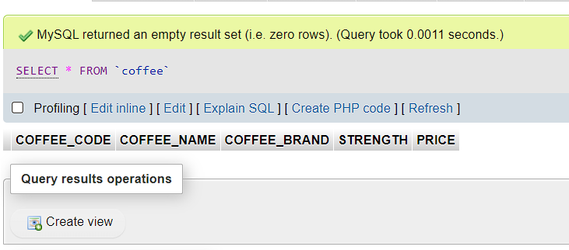

CREATE TABLE STORES(

STORE_CODE VARCHAR(5) NOT NULL PRIMARY KEY,

STORE_NAME VARCHAR(20) NOT NULL,

STORE_ADDRESS VARCHAR(50) NOT NULL,

CITY VARCHAR(20) NOT NULL

);

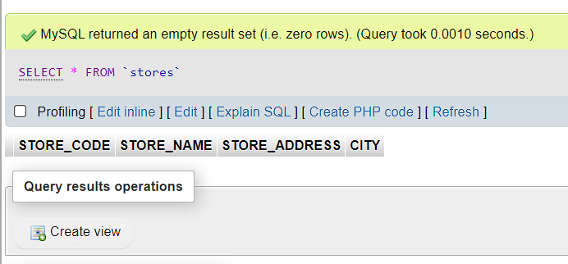

CREATE TABLE AVAILABILITY (

COFFEE_CODE VARCHAR(5) NOT NULL,

STORE_CODE VARCHAR(5) NOT NULL,

AVAILABLE_STOCK SMALLINT NOT NULL,

CONSTRAINT FK_AVAILABILITY_COFFEE FOREIGN KEY (COFFEE_CODE) REFERENCES COFFEE(COFFEE_CODE),

CONSTRAINT FK_AVAILABILITY_STORES FOREIGN KEY (STORE_CODE) REFERENCES STORES(STORE_CODE)

);

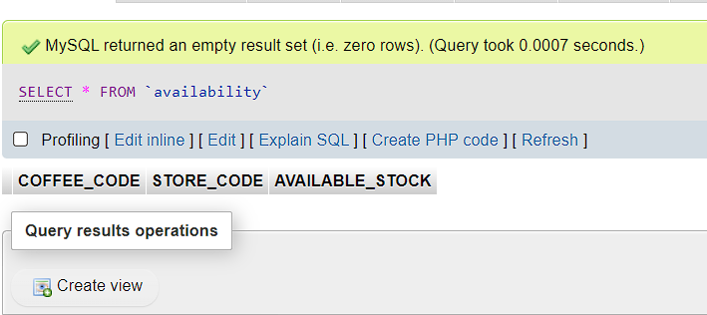

***Question 2***

INSERT INTO COFFEE (COFFEE_CODE, COFFEE_NAME, COFFEE_BRAND, STRENGTH, PRICE)

VALUES

('C001', 'San Remo', 'Roastmasters', '9', '350'),

('C002', 'Sweet Italian Blend', 'Mastertons', '5', '230'),

('C003', 'The Great Dane', 'Terbodore', '8', '365'),

('C004', 'Black Honey', 'Truth Coffee', '6', '117'),

('C005', 'Pure Arabica', 'Hazz Coffee', '7', '95');

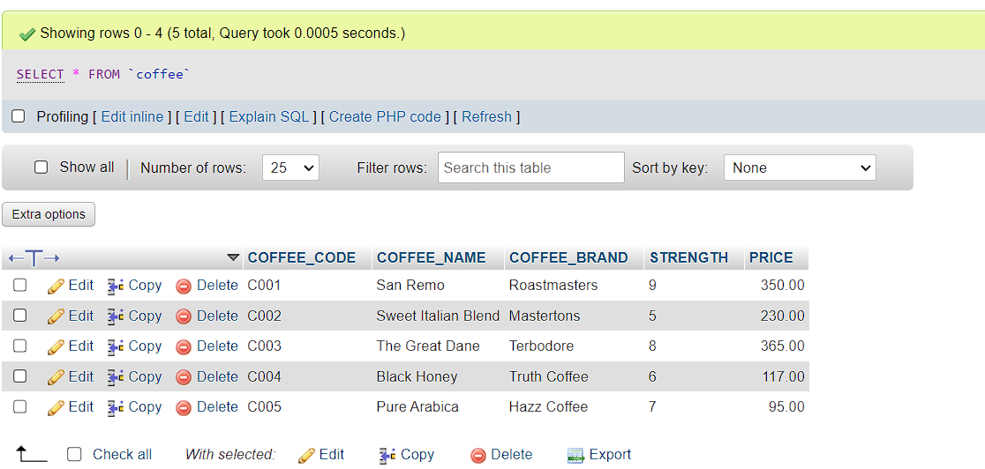

INSERT INTO STORES (STORE_CODE, STORE_NAME, ADDRESS, CITY)

VALUES

('ST001', 'Local Grind', '167 Pert Road', 'Johannesburg'),

('ST002', 'Club Coffee', '5 Second Avenue', 'Gqeberha'),

('ST003', 'Boston Barista', '33 Bertha Mkhize Street', 'Durban'),

('ST004', 'Jacked Up Coffee', '27 Bram Fischer Road', 'Durban'),

('ST005', 'Impresso Espresso', '210 Du Toit Street', 'Tshwane');

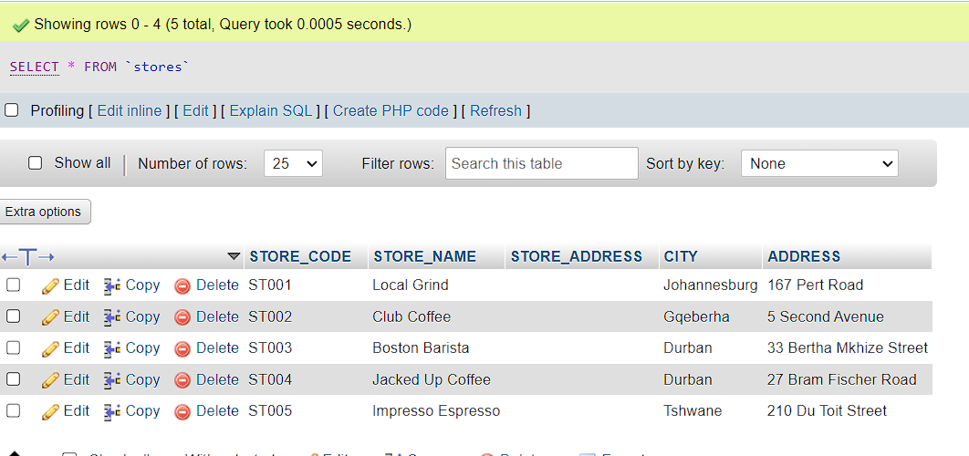

INSERT INTO AVAILABILITY

(COFFEE_CODE, STORE_CODE, AVAILABLE_STOCK)

VALUES

('C002', 'ST001', '13'),

('C002', 'ST004', '9'),

('C003', 'ST005', '8'),

('C004', 'ST003', '5'),

('C004', 'ST001', '9');

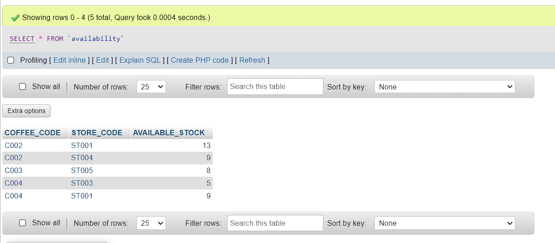

***Question 3***

ALTER TABLE AVAILABILITY

ADD STOCK_ORDERED SMALLINT;

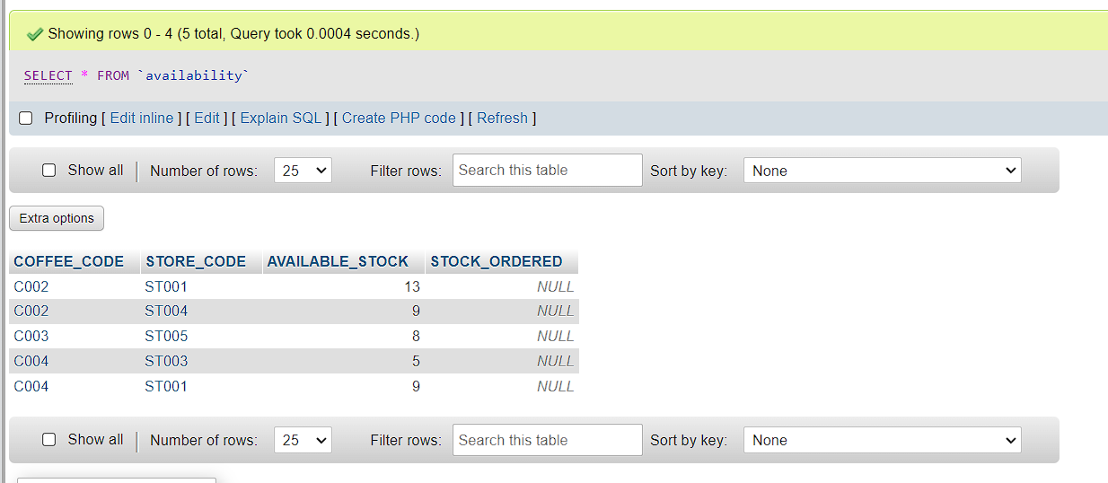

***Question 4***

UPDATE AVAILABILITY

SET STOCK_ORDERED=3

WHERE COFFEE_CODE= 'C004' AND STORE_CODE='ST003';

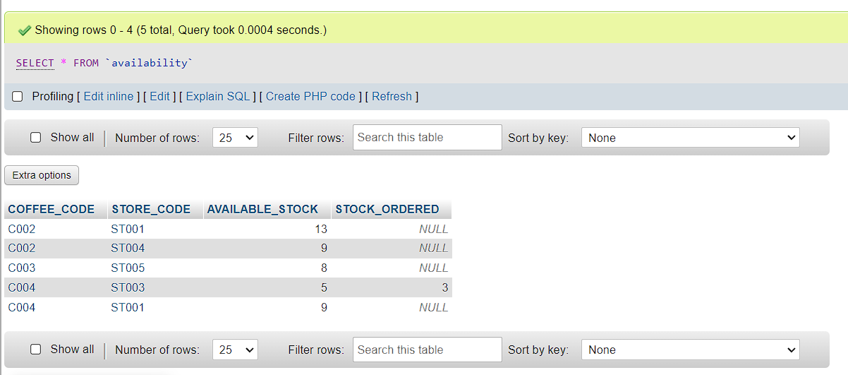

***Question 5***

SELECT COFFEE.COFFEE_NAME,

COFFEE.COFFEE_BRAND,

AVAILABILITY.AVAILABLE_STOCK

FROM COFFEE

LEFT JOIN AVAILABILITY ON

COFFEE.COFFEE_CODE = AVAILABILITY.COFFEE_CODE;

